Miguel Fernandez Brazon
2/8/2026
Module 4.2 Assignment
Connection:
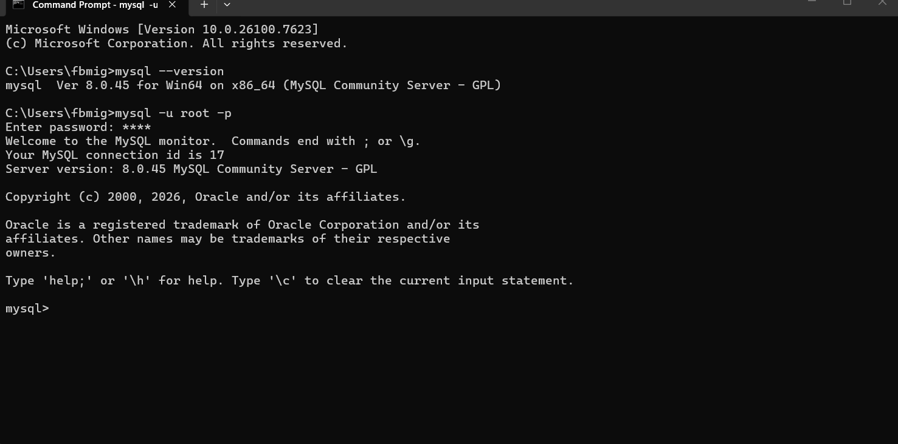
Create Table:
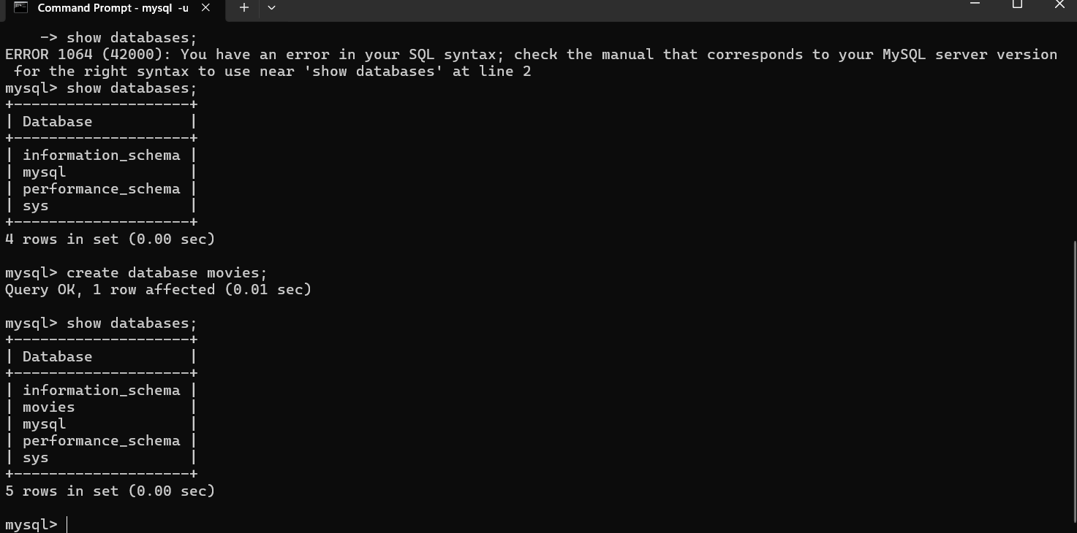
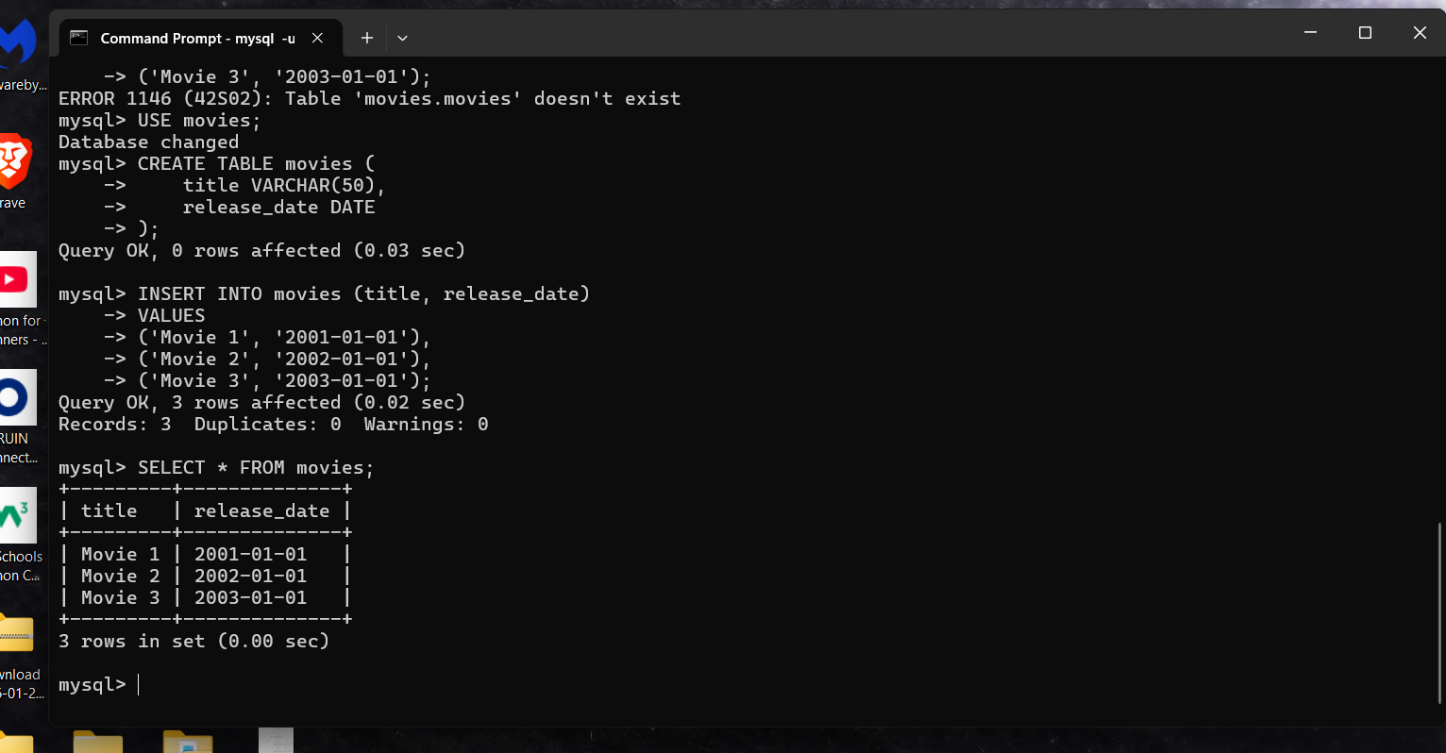

UPPER() Convert text to uppercase use for formatting titles

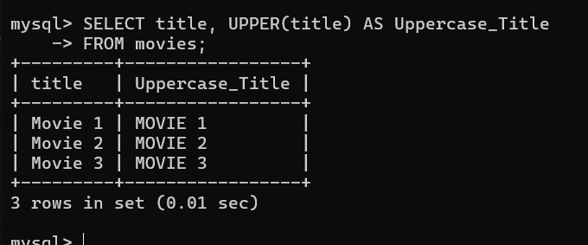

LENGTH() Find how many characters in a tittle

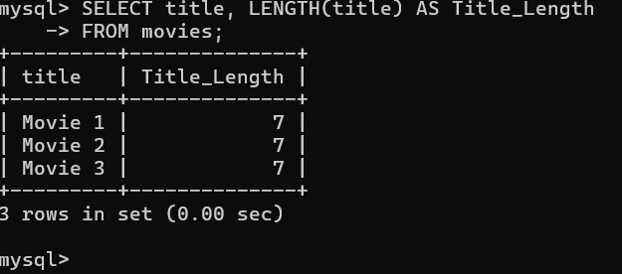

YEAR() Extract the year from a date

